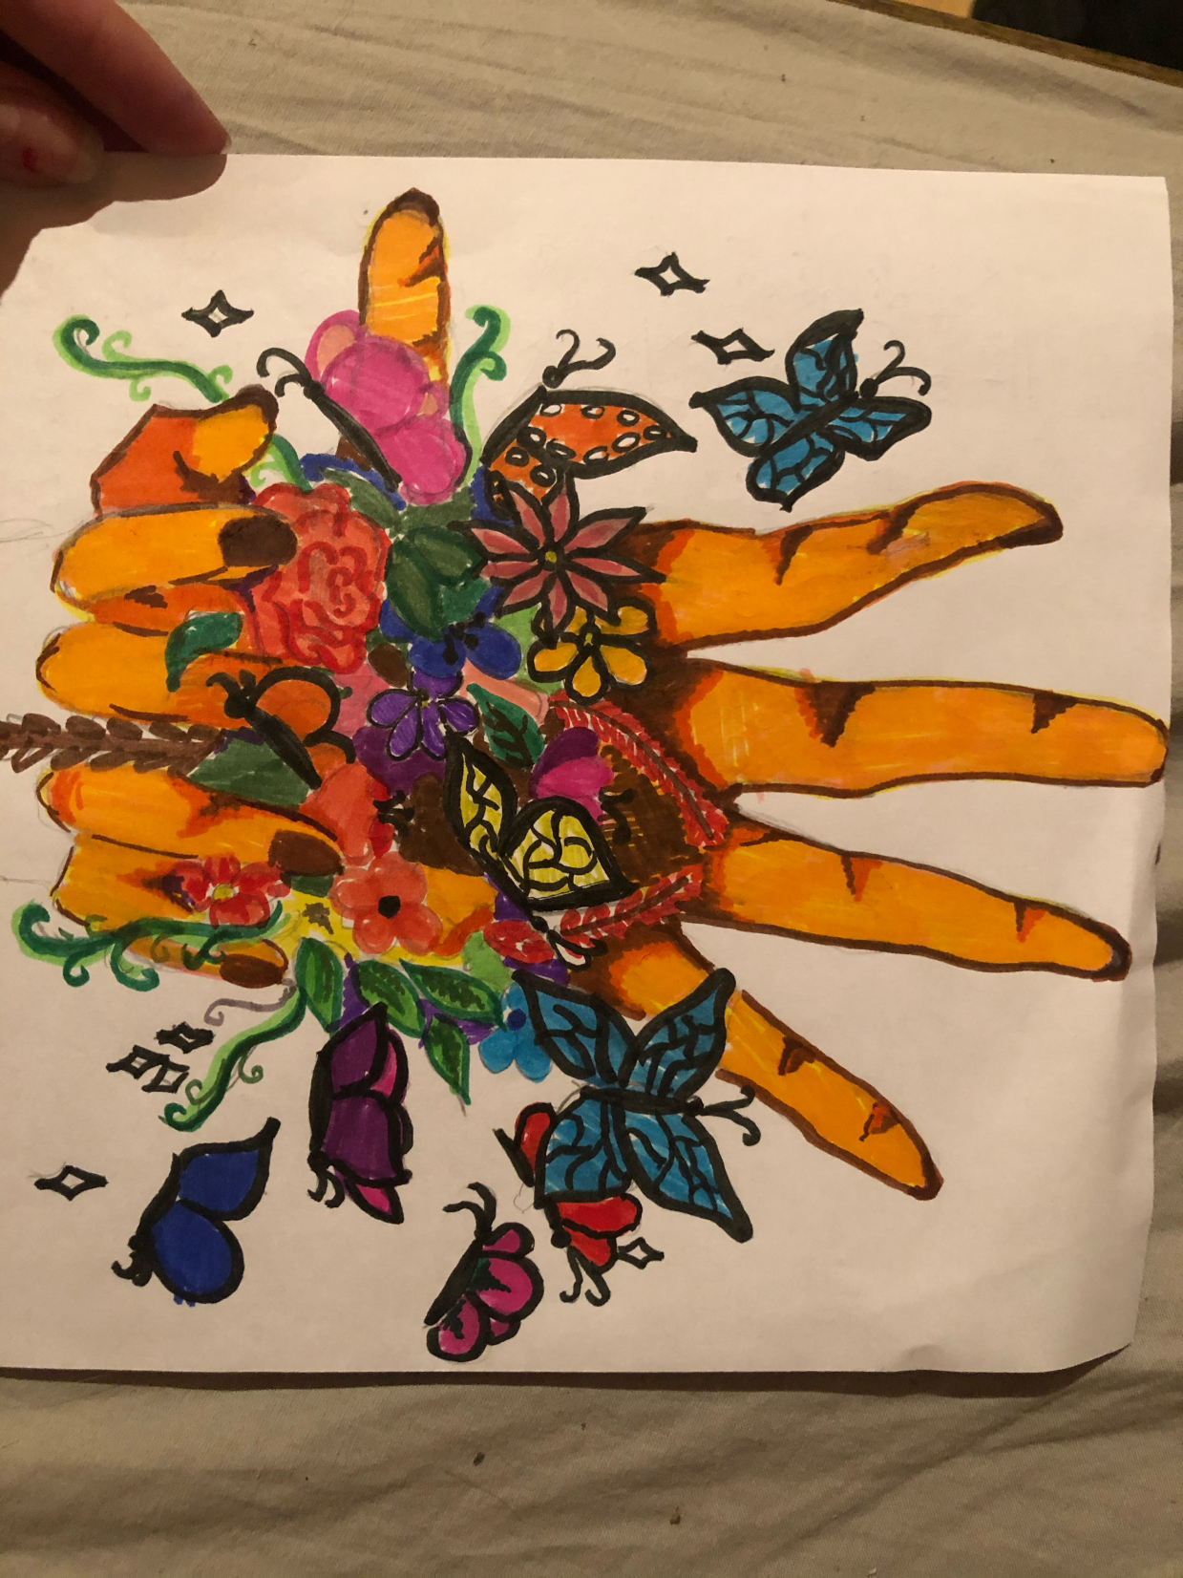
Un dibujo de apoyo para señora Jani Silva …
Vanesa de Eslovenia
We call on the President of Colombia to:
Ensure that Jani Silva and the colleagues she work with, have access to a collective protection plan.

